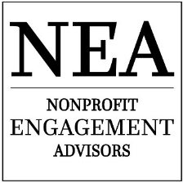
www.4NEA.com
9404 NE 8th St.
Vancouver, WA
98664-3328
(844) 336-9900
@4NEAnow

Grant Template

STANDARD INFORMATION REQUIRED:

Mailing Address:

Email:

Phone:

Web:

Facebook:

Twitter:

Instagram:

(other social media)

Tax ID:

State Attorney General and the Secretary of State. Registration #

State Charity Registration #

Dunn and Bradstreet Number:

DOCUMENTATION NEEDED:

IRS determination letter

Current organizational budget

Current program/event budget

Financials (Audited if possible)

Board List with affiliations

Last 990 filed with the IRS

W9 form

Indirect rate certificate from government office (if needed)

Program Overview/Brochure

Non-discrimination policy

Testimonials including but not limited to video, pictures, stories.

Program metrics: measuring impact of the program over time

BASIC QUESTIONS

Mission Statement

History

Program Overview

BASIC QUESTIONS

Need For Program (provide evidence)

Program Objectives

Measuring and Evaluating Outcomes

BASIC QUESTIONS

Program Timeline and Milestones

Target Audience

Cultural/Diversity Policy (Plan)

Sustaining Over Time

BASIC QUESTIONS

Community Support

Funding Sources:

Source Amount Current Requested Status

